Bus Stop Buddy

by: Swole Team 6

Lamis Alqafshat, Brian Freeman, Luke Jeries, Dennis Kellogg, Taylor Shephard, Dan Wiseman

SLACK CHANNEL: CSC-383.slack.com

Final Document

For: Dr. Mark Allison

On: 4/18/17

Available at: https://github.com/TacticalLuke43/BusStopBuddy

**Table of Contents**

**Abstract 3**

*1.1. Purpose of System 4*

*1.2. Scope of System 4*

*1.3. Development Methodology 4*

*1.4. Definitions, Acronyms, and Abbreviations 4*

*1.5. Overview of Document 5*

**2. Current System 6**

**3. Project Plan 6**

*3.1. Project Organization 6*

*3.2. Software and Hardware Requirements 7*

*3.3. Work Breakdown 7*

*3.4 Risk Management Table 8*

*3.5 CoCoMo Chart 9*

**4. Requirements of System 9**

*4.1. Functional and Nonfunctional Requirements 9*

*4.2. IDENTIFY Personas 9*

*4.3. Use Case Diagram 10*

*4.4. Requirements Analysis 11*

**5. Software Architecture 12**

*5.1. Overview 12*

*5.2. Subsystem Decomposition 13*

*5.3. Persistent Data Management 15*

**6. Object Design 15**

*6.1. Overview 15*

*6.2. Object Interaction 15*

*6.3. Detailed Class Design 15*

**7. Testing Process 16**

**8. Glossary 16**

**9. Appendix 17**

*9.1. Appendix A – Gantt Chart 17*

*9.2. Appendix B – Use Cases 18*

*9.3. Appendix C – User Interface Designs 18*

*9.4. Appendix D – Class Interfaces for Implemented Subsystems 21*

# 

# **Abstract**

Swole Team 6 proposes creating a bus tracking system called Bus Stop Buddy that includes many features. Some of those features will be showing the route of a specific bus (selected by the user), the predicted arrival of the bus and if it is late, and enabling the students to log into and display this information in real time. The system will also maintain information about the parents and students for contact information in case the need arises.

The application will also have the ability to track multiple busses at once. Any user can get the notifications of the buses whereabouts and if they are on schedule. The application will also allow the user to input whether a pickup is necessary or not and if the student is authorized to ride a specific bus.

**1. Introduction**

In this chapter, we will introduce the motivation for building the system

## ***1.1. Purpose of System***

The purpose of the system is to give students and parents a way to track their associated school bus and know what time it should arrive at each stop.

## ***1.2. Scope of System***

The system will allow parents to track the bus and get real time notification of when their children are being picked up from school and dropped off at home. The system will also allow the parent to view the bus driver’s information and vice versa so if problems arise, they can contact one another.

## ***1.3. Development Methodology***

Since agile is all about working with the business people to get exactly what they want throughout all phases of the project we have a few ways to do so. Currently one of our members has a family member that works as a bus driver and he is acting as our business person. One of our developers is working with him to figure out exactly what kinds of features he would want in a bus tracking software system.

Since then our developer has gotten a list of requirements from him along with some extras that our other developers came up with. At our next meeting, we are going to talk about all these requirements that are necessary to make this project tick along with some extras that are going to make it above and beyond expectation.

## ***1.4. Definitions, Acronyms, and Abbreviations***

Actors:External entities that interact with the system.

Agile:A method of development.

School:Educational institution for children.

ETA:Estimated Time of Arrival.

GPS:Global Positioning System.

## ***1.5. Overview of Document***

The grand scheme of this is to deliver an application that parents can install on their phones so they can pinpoint exactly when their children will be home.

# **2. Current System**

Not applicable

# **3. Project Plan**

## ***3.1. Project Organization***

**Phase 1 (1/16/2017-2/3/2017)**

| Brian Freeman | Editor |
| --- | --- |
| Dennis Kellogg | System Architect |
| Luke Jeries | Leader |
| Taylor Shephard, Lamis Alqafshat | Minute Keeper |
| Dan Wiseman | Secretary/Diary Keeper |

**Phase 2 (2/3/2017-3/2/2017)**

| Taylor Shephard | Leader |
| --- | --- |
| Brian Freeman, Dan Wiseman | Validater/Architect |
| Lamis Alqafshat | Minute Keeper |
| Luke Jeries | Diary Keeper/Tester |
| Dennis Kellogg | Editor |

## ***3.2. Software and Hardware Requirements***

Hardware: Smartphone and the ability to download an application

Software:iOS, Android OS

## ***3.3. Work Breakdown***

| **Task #** | **Task** | **Description** | **Duration** | **Dependencies** |
| --- | --- | --- | --- | --- |
| 1 | Team Introduction | Get to know team members, consider strengths and weaknesses, brainstorm project topic | 7 days |  |
| 2 | Project Idea Development | Cultivate existing project idea, consider all potential uses, consider potential challenges | 7 days | 1 (M1) |
| 3 | Use Case Creation | Refine proposed features into clear use cases | 3 days |  |
| 4 | Use Case Completion | Submit Use Case diagram for review, consider future Contextual Use Case details | 4 days | 3 (D1) |
| 5 | Persona Research | Consider relevant users, begin consideration of Personas | 3 days |  |
| 6 | Documentation - SFD | SFD Stages 1-4.3 | 3 days | 2, 4 (M2) (D2) |
| 7 | Software Architecture | Divide Project into subsystems, identify objects, finalize member roles for development | 3 days | 6 |
| 8 | Object Design | Develop models into workable code/design | 14 days | 7 |
| 9 | Implementation Phase 1 | Begin coding and auxiliary software implementation | 20 days | 8 |
| 10 | Review of Implementation 1 | Members all reconvene for group reflection | 4 days | 9 (M3) |
| 11 | Implementation Phase 2 - Final | Finalize basic development | 14 days |  |
| 12 | "Hands on" Testing | Rigorous testing while working with key developer(known problems) | 7 days | 9, 11 (M4) (D3) |
| 13 | "Hands off" Testing | Testing with no insight from key developer(finding unknown problems) | 7 days |  |
| 14 | System Familiarity Development | Bring all members up to speed with status/details of sub systems | 2 days | 9, 11 |
| 15 | Creation of FD | Complete FD, begin Power Point | 20 days | (M5) (D4) |
| 16 | Final Presentation | Present and submit FD | 1 day | 15 |

M – Milestone D – Deliverable

# *3.4 Risk Management Table*

# 

# *3.5 COCOMO Cost Estimate*

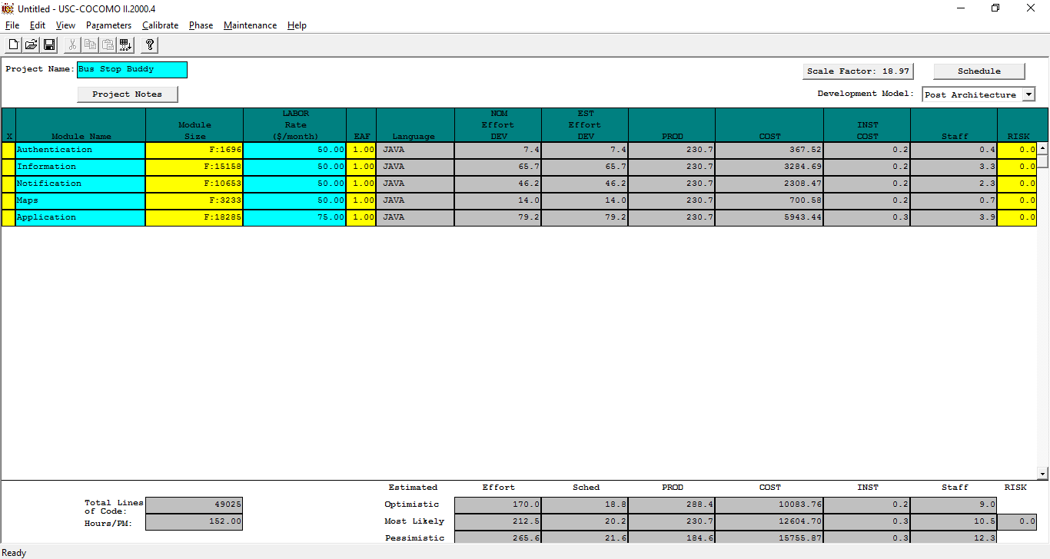

# 

# 

# 

# 

# **4. Requirements of System**

The system we are proposing

## ***4.1. Functional and Nonfunctional Requirements***

Functional: App, GPS tracking, ETA Estimates, Contact Information, Map, All these features for all busses.

Nonfunctional: Show route on map, program to display bus info at school, Features to get ETA, Alarm Notification for student pickup and drop off, student to bus correlation, Ability to select other busses, RFID

## ***4.2. IDENTIFY Personas***

Parents: Busy people with tight schedules that need to know when their child or children will be leaving school and arriving home.

Drivers: Pick the kids up from school and drop them off at home. Need to be able to let parents know when the kids are being picked up and being dropped off. Along with alerting parents of emergencies

Students: The children being picked up and dropped off. They need to be able to check into the bus and Check out of the bus.

School Faculty: Work at the school and look out for the general well being of the children. Need to know when the students get on the bus and when the students are dropped off the bus. Also need to be able to track the bus to see where it’s at and if has ran into any issues.

## ***4.3. Use Case Diagram***

The next figure depicts the interaction between the actors and the previously described use cases. A description for each actor follows.

Parent: The main user of the application, guardian of the student.

Student: Rides the bus, could be in elementary/middle/high school

Driver: Operates the bus

School: Owner of the bus, manages the bus

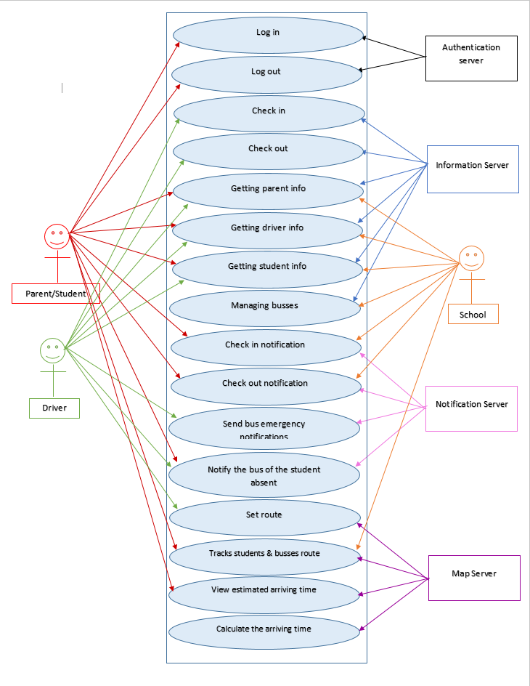

*Figure 1: Use Case Diagram*

## ***4.4. Requirements Analysis***

After considering our own goals for the project as well as the concerns of some of our stakeholders(both bus drivers and parents), we believe that our use case and the requirements it reflects wholly encompass the needs of anyone hoping to use the app. Keeping the user experience at the forefront of our design process, we can move forward towards fleshing out our system details and implementing all of the planned helpful functions of Bus Stop Buddy.

# **5. Software Architecture**

.

## ***5.1. Overview***

Upon considering the inherent nature of an app like ours, following a Client-Server architectural pattern made the most sense for this project. Every user's device will connect with our FireBase cloud server in order to ensure everyone views the same data.

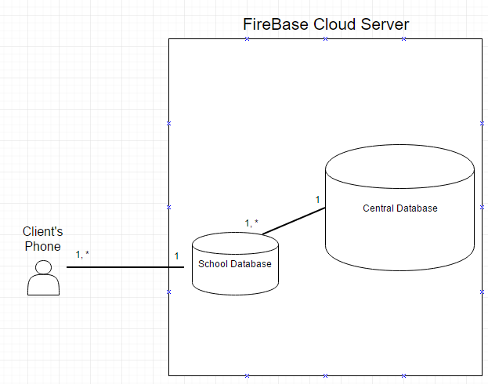

Figure 1: Basic Client-Server Architecture

## ***5.2. Subsystem Decomposition.***

# Snip 1.PNGSnip 2.PNG

## ***5.3. Persistent Data Management***

# Firebase(Cloud) Storage

# - Driver Information

# - Bus Routes

# - Student Information

# - Parent Information

# - School Information

# Device Storage

# - Personal Settings

# - Remember Username

# - Remember Password

# **6. Object Design**

The architecture we chose was client-server architecture. The main reasons we chose this architecture is because the way the users interact with each other.

## ***6.1. Overview***

This application was designed with the evolutionary model. The main reason we chose this model is because we knew that there were going to be changes made in the future depending on what works and what doesn't.

## ***6.2. Object Interaction***

The way the object interact in our application is that the user’s interact with the server. The driver object interacts with the server by telling the server his/her information along with the notifications that a specified child has gotten on/off the bus or if a incident has occurred. The parent object interacts with the system by retrieving data from the driver about the whereabouts of their child and what the estimated time of arrival of their child is. Also the parent interacts with the server by uploading their contact information. The student object interacts with the driver object to let the driver know that they are on the bus.

## ***6.3. Detailed Class Design***

Driver

__________________________________________________________________________________

* Collection: Persons
* Count: int (drivers = # of busses)
* File = Number of driver info files

__________________________________________________________________________________

* Driver()
* getNumberOfDrivers(): int
* addPerson(String firstName, String lastName, String address, String city, String state, String zip, String phone)
* getFullNameofPerson(int index): String
* getOtherPersonInformation(int index): String[]
* updatePerson(int index, String address, String city, String state, String zip, String phone)
* removePerson(int Index)
* sortByName()
* sortByZip()
* printAll()
* getFile(): File
* getTitle(): String
* setFile(File file)
* getChangedSinceLastSave(): boolean
* setChangedSinceLastSave(boolean changedSinceLastSave)

__________________________________________________________________________________

Parent

__________________________________________________________________________________

* Collection: Persons
* Count: int (parent = #of students)
* File = Number of parent info files

__________________________________________________________________________________

* Parent()
* getNumberOfParents(): int
* addPerson(String firstName, String lastName, String address, String city, String state, String zip, String phone)
* getFullNameofPerson(int index): String
* getOtherPersonInformation(int index): String[]
* updatePerson(int index, String address, String city, String state, String zip, String phone)
* removePerson(int Index)
* sortByName()
* sortByZip()
* printAll()
* getFile(): File
* getTitle(): String
* setFile(File file)
* getChangedSinceLastSave(): boolean
* setChangedSinceLastSave(boolean changedSinceLastSave)

__________________________________________________________________________________

Student

__________________________________________________________________________________

* Collection: Persons
* Count: int (Student = #ofStudents)
* File = Number of Student info files

__________________________________________________________________________________

* Student()
* getNumberOfStudents(): int
* addPerson(String firstName, String lastName, String address, String city, String state, String zip, String phone)
* getFullNameofPerson(int index): String
* getOtherPersonInformation(int index): String[]
* updatePerson(int index, String address, String city, String state, String zip, String phone)
* removePerson(int Index)
* sortByName()
* sortByZip()
* printAll()
* getFile(): File
* getTitle(): String
* setFile(File file)
* getChangedSinceLastSave(): boolean
* setChangedSinceLastSave(boolean changedSinceLastSave)

__________________________________________________________________________________

# **7. Testing Process**

7.1. User Experience Tests

Testing the system largely fell to us, the developers. In order to ensure that we had a good and functional product, we each used the apps on our own phones and simulated specific tasks in order to ensure that all features were functional. These primarily consisted of viewing the various information contained on the menus(View Routes, View Student Check Ins, etc.), and creating new entries for the various users(Edit Student/Parent/Driver info). From these tasks, we made slight adjustments in the design of our user interface in order to make it consistent across all screens within the app, as well as make it more intuitive and easy to use.

7.2. Systems Tests

The system tests proved to be invaluable, as we did very little in the way of integration testing. Many bugs and inconsistencies had arisen during the development of our different modules that were not caught due to our lack of proper use of version control. Thankfully, the systems test we performed caught a lot of the abnormal behavior, and we were able to correct it.

7.3 Subsystems Tests

Due to the more simplistic nature of our in class demo compared to the scope and functionality of our entire planned project, our subsystems tests were mostly done to verify basic functionality. Making sure that all buttons behave as expected proved to be the most time consuming part of this process. Copy and pasted code proved to be a major problem, as this lack of care led to many difficult to track down bugs in the simple navigation of our app. In the end though, with each member contributing to the testing of their modules during their respective development phases, each subsystem behaved as expected. Presented are several test cases which unveiled major issues while creating the system.

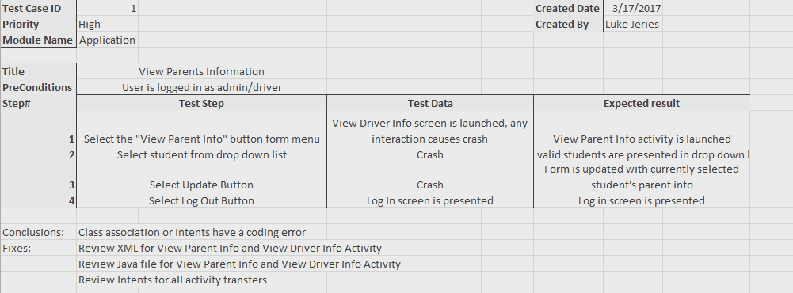

Figure 1: Application Module Test - Class association error

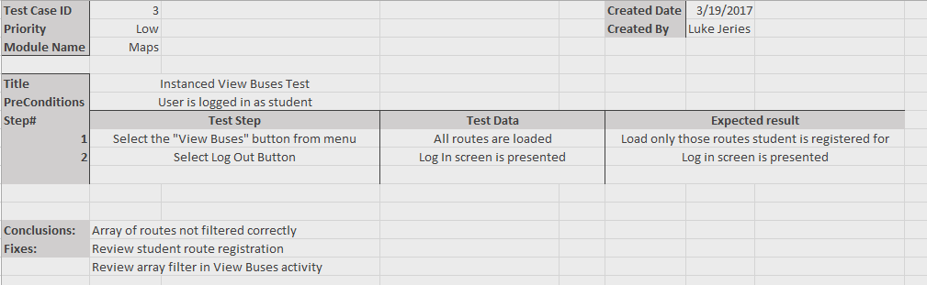

Figure 2: Maps Module Test - Instanced user maps error

# **8. Glossary**

# **9. Appendix**

## ***9.1. Appendix A – Gantt Chart***

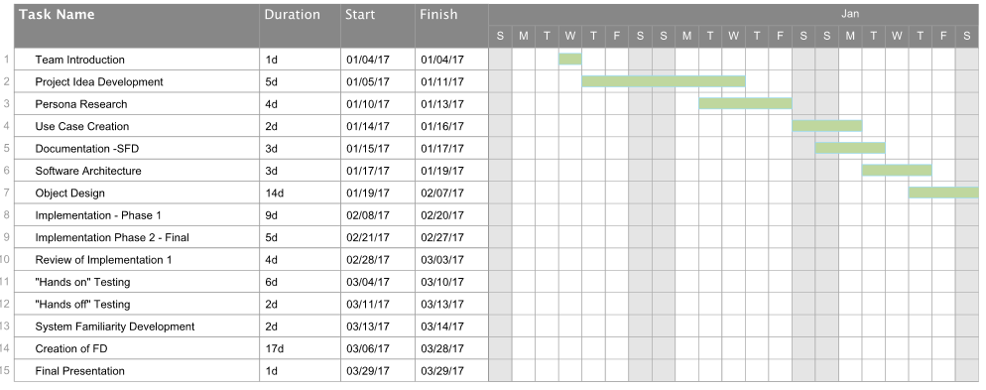

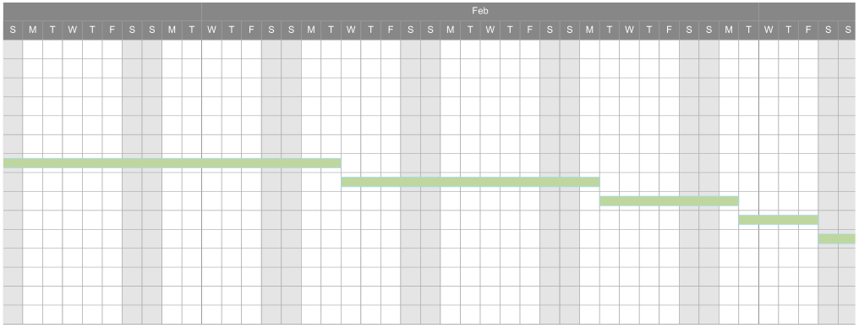

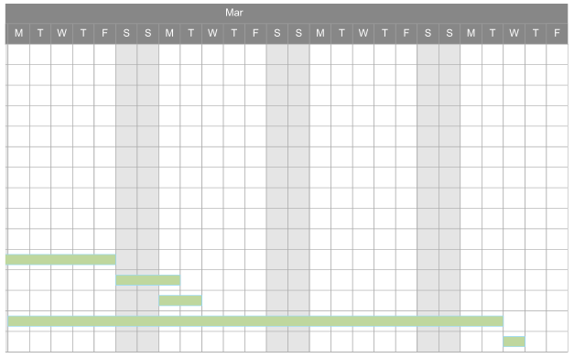

## ***9.2. Appendix B – Use Cases***

**Use Cases**

Use Case ID: BSB01 - Manage Routes

Scenario:

Actor: Administrator

Pre-conditions:

1. Administrator is logged in to the system.

Description:

1. Use case begins when the Administrator selects the “Administrator Features” option from the app menu.
2. The system presents the user with the Administrator Features menu.
3. Administrator selects the Manage Routes option from the menu.
4. System retrieves route list for Administrator’s registered school.
5. System presents list of routes to user.
6. Administrator selects the route they wish to modify.
7. System pulls up detail form for selected route.
8. Administrator changes desired details of route and hits “submit changes”
9. Use Case ends when system updates form and returns Administrator to Administrator Features menu.

Post Conditions:

1. School’s route list has been permanently updated.

Alternate Course of Action:

1. In Step D6, Administrator may select to add a new route rather than modify existing.

Related Use Cases:

Log in

Decision Support:

Frequency: After initial set up, route adjustments should be limited. About 3 per month in regular use.

Criticality: High. Creation of routes is the core feature of setting up the system.

Risk: Medium. Use case employs modification of server info.

Constraints:

Route list should be available to modify >90% of each 24 hour day.

Use Case ID: BSB02 – Send Bus Emergency Notification

Scenario:

Actor: Driver

Pre-conditions:

1. User is logged in to the system.

Description:

1. Use case begins when a registered Driver selects “Send Emergency Update” from app menu.
2. System presents the Update form to user.
3. Users enters text detailing desired broadcast message.
4. System sends notification to all users registered to that Driver’s route.
5. Use case ends when system returns user to app menu.

Exceptions:

1. User is not a registered Driver.
2. Driver has no associated routes.

Related Use Cases:

Log in

Decision Support:

Frequency: Low. Updates should be few and far between.

Criticality: Low. Emergency Updates are a non-essential feature, merely quality of life.

Risk: Medium. Use case employs modification of server info and push notifications.

Constraints:

Emergency Updates are pushed to users within 1 minute.

Use Case ID: BSB01 - Manage Routes

Scenario:

Actor: Administrator

Pre-conditions:

1. Administrator is logged in to the system.

Description:

1. Use case begins when the Administrator selects the “Administrator Features” option from the app menu.
2. The system presents the user with the Administrator Features menu.
3. Administrator selects the Manage Routes option from the menu.
4. System retrieves route list for Administrator’s registered school.
5. System presents list of routes to user.
6. Administrator selects the route they wish to modify.
7. System pulls up detail form for selected route.
8. Administrator changes desired details of route and hits “submit changes”
9. Use Case ends when system updates form and returns Administrator to Administrator Features menu.

Post Conditions:

1. School’s route list has been permanently updated.

Alternate Course of Action:

1. In Step D6, Administrator may select to add a new route rather than modify existing.

Related Use Cases:

Log in

Decision Support:

Frequency: After initial set up, route adjustments should be limited. About 3 per month in regular use.

Criticality: High. Creation of routes is the core feature of setting up the system.

Risk: Medium. Use case employs modification of server info.

Constraints:

Route list should be available to modify >90% of each 24 hour day.

Use Case ID: BSB02 – Send Bus Emergency Notification

Scenario:

Actor: Driver

Pre-conditions:

1. User is logged in to the system.

Description:

1. Use case begins when a registered Driver selects “Send Emergency Update” from app menu.
2. System presents the Update form to user.
3. Users enters text detailing desired broadcast message.
4. System sends notification to all users registered to that Driver’s route.
5. Use case ends when system returns user to app menu.

Exceptions:

1. User is not a registered Driver.
2. Driver has no associated routes.

Related Use Cases:

Log in

Decision Support:

Frequency: Low. Updates should be few and far between.

Criticality: Low. Emergency Updates are a non-essential feature, merely quality of life.

Risk: Medium. Use case employs modification of server info and push notifications.

Constraints:

Emergency Updates are pushed to users within 1 minute.

*Use Case ID:* **Calculate Arriving Time**

*Scenario:*

*Actor:*Parent/Student user.

*Pre-conditions:*

* 1. User has successfully logged onto the system.
  2. Web page has been activated.

*Description:*

1. Use case begins when parent/student user clicks on the Calculate Arrival Time Button in the selection menu
2. The system shall validate the information
3. User shall select which bus they desire to view (request)
4. The user shall then send the request by selecting the **send** button.
5. The system shall then notify the parent/student user if the request was submitted correctly.
6. When the request is received, the system shall generate the ETA
7. System shall display the map and time of arrival
8. Use case ends when the user closes

*Post-conditions:*

1. The estimated time of arrival is estimated
2. Estimated time of arrival is updated and stored in the system

*Alternative Courses of Action:*

1. In step D.4 (step 4 of Description section) the user has the option to cancel the request.
2. In step D.6 if any of the required fields are incorrect the system shall request the user to make a correction in the appropriate field.

*Exceptions:*

1. There are no busses running at this time.

*Related Uses Case:*

None.

------------------------------------------------------------------------------------------------------------

**Decision Support:**

*Frequency:* On average 10 requests are made daily by parent/student user.

*Criticality:* High. Main objective of the program

*Risk:* High. Implementing this use case employs drivers login, gps tracking systems, refresh rates

*Constraints:*

Non-functional requirements

------------------------------------------------------------------------------------------------------------

**Modification History:**

*Owner:* Swole Team 6

*Initiation date:* 02/15/2017

*Date last modified:* 02/15/2017

*Use Case ID:* **Calculate Arriving Time**

*Scenario:*

*Actor:*Parent/Student user.

*Pre-conditions:*

* 1. User has successfully logged onto the system.
  2. Web page has been activated.

*Description:*

1. Use case begins when parent/student user clicks on the Calculate Arrival Time Button in the selection menu
2. The system shall validate the information
3. User shall select which bus they desire to view (request)
4. The user shall then send the request by selecting the **send** button.
5. The system shall then notify the parent/student user if the request was submitted correctly.
6. When the request is received, the system shall generate the ETA
7. System shall display the map and time of arrival
8. Use case ends when the user closes

*Post-conditions:*

1. The estimated time of arrival is estimated
2. Estimated time of arrival is updated and stored in the system

*Alternative Courses of Action:*

1. In step D.4 (step 4 of Description section) the user has the option to cancel the request.
2. In step D.6 if any of the required fields are incorrect the system shall request the user to make a correction in the appropriate field.

*Exceptions:*

1. There are no busses running at this time.

*Related Uses Case:*

None.

------------------------------------------------------------------------------------------------------------

**Decision Support:**

*Frequency:* On average 10 requests are made daily by parent/student user.

*Criticality:* High. Main objective of the program

*Risk:* High. Implementing this use case employs drivers login, gps tracking systems, refresh rates

*Constraints:*

Non-functional requirements

------------------------------------------------------------------------------------------------------------

**Modification History:**

*Owner:* Swole Team 6

*Initiation date:* 02/15/2017

*Date last modified:* 02/15/2017

*Use Case ID:* Get driver information

*Scenario:*

*Actor:*driver, school, info server

*Pre-conditions:*

1. driver register to the system

2. driver Enter his/her information

3. driver Submit request

4. School sends information to the parents and students

*Description:*

1. Use case begins driver download the application

2. When the driver open the application the start screen should show log in and register options

3. driver will click in register and the system will take him to the register page

4. The system will ask the user to enter the ID number.

5. Driver enter ID number

6. System will display the information page.

7. Driver will enter his/her information: name, contact

8. Driver click in Submit bottom to send the request.

9. School receive the driver request and save the new driver information in the info server

10. Use case ends send information to the students or parents in the area the driver will go to

*Post-conditions:*

*1.*

*Alternative Courses of Action:*

1. In step D.8 (step 4 of Description section) the user has the option to cancel the request.

2. In step D.8 if any of the required fields are blank the system shall request the user to make an entry in the appropriate field.

3. In step D.4 the system will choose the category (student, parent, or driver) from the ID number and display the correct application.

*Exceptions:*

*Related Uses Case:*

None

------------------------------------------------------------------------------------------------------------

## ***9.3. Appendix C – User Interface Designs***

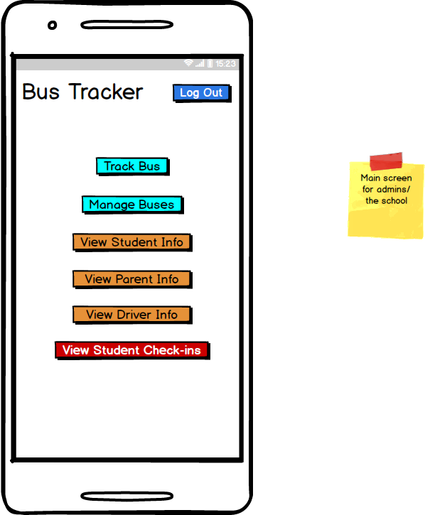

Figure 1: Admin Main Menu

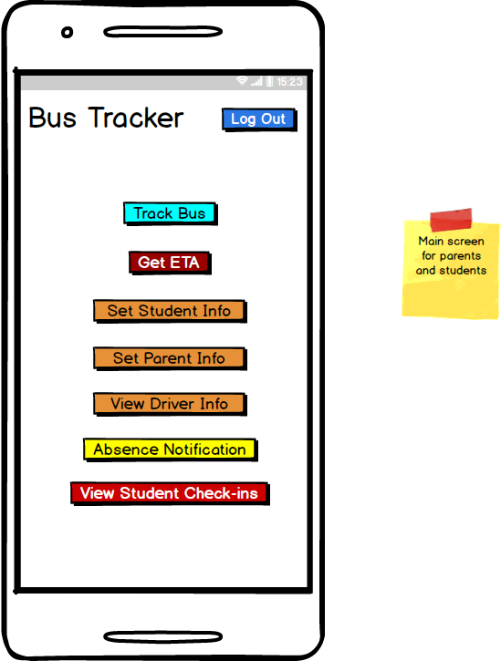

Figure 2: Parents Main Menu

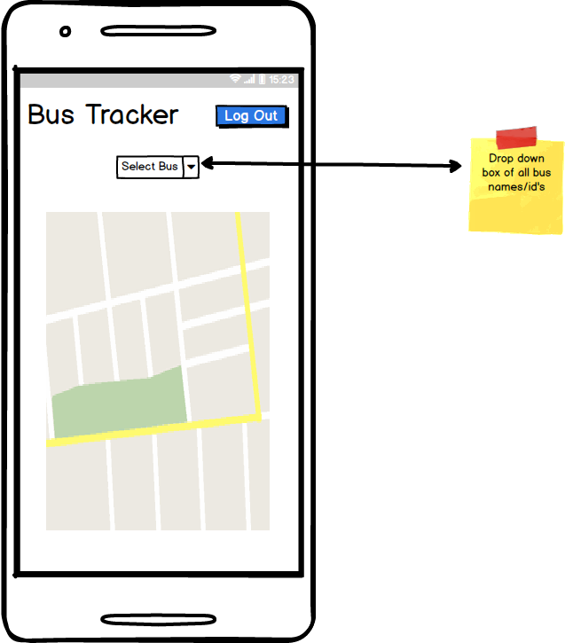

Figure 3: Bus Tracker Main Screen

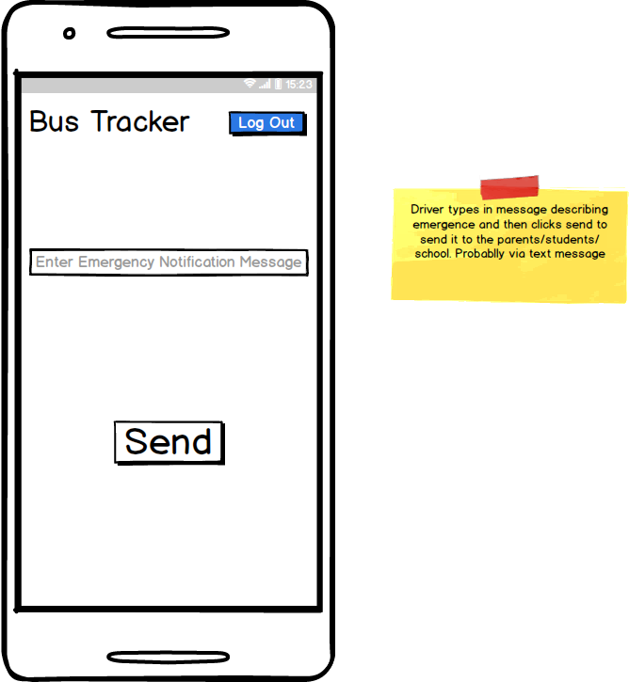

Figure 4: Emergency Notifications

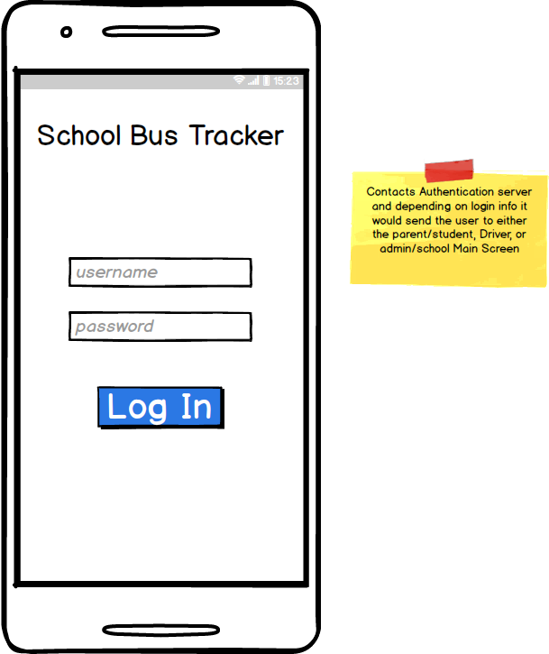

Figure 5: Log In Screen

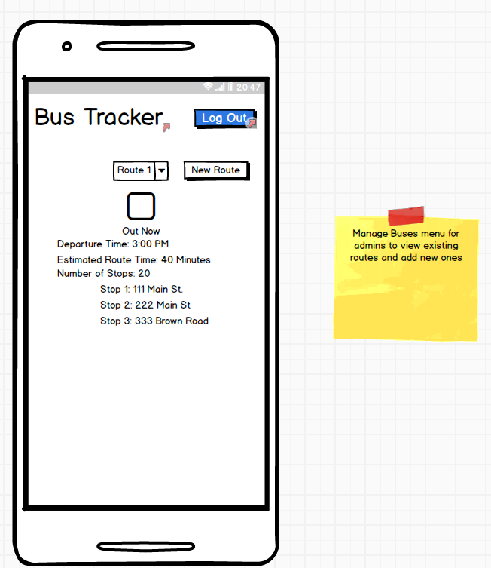

Figure 6: Manage Buses Screen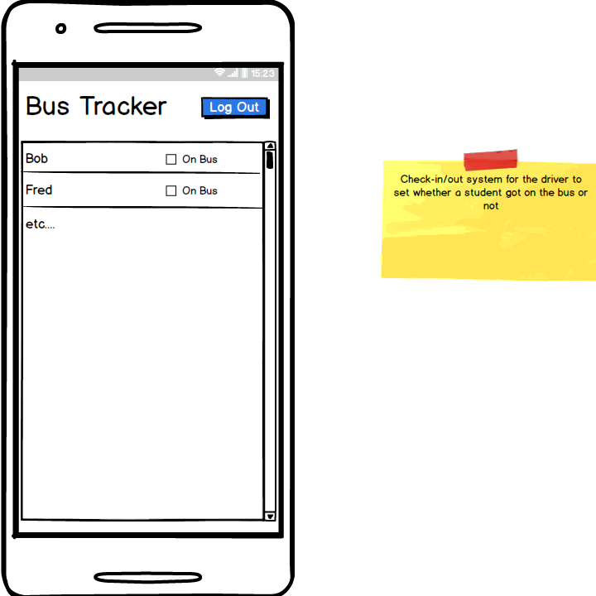

Figure 7: Student Check In Screen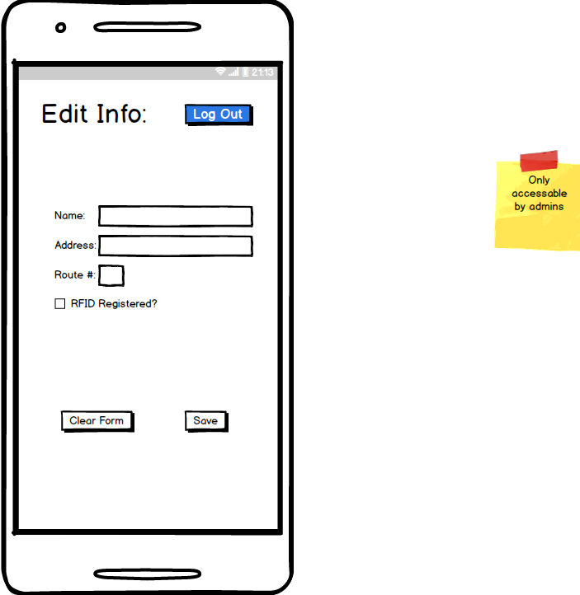

Figure 8: Edit Info Screen

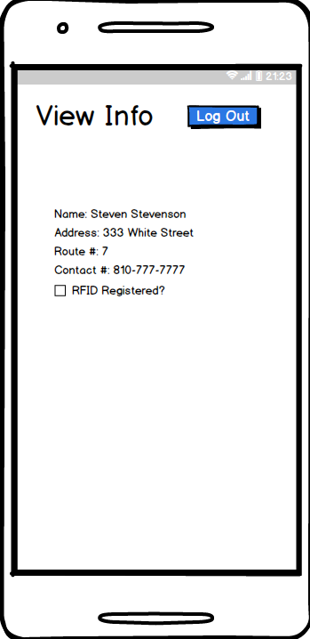

Figure 9: View Info Screen

## ***9.5. Appendix D – Class Interfaces for Implemented Subsystems***